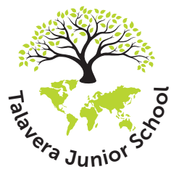

TALAVERA JUNIOR SCHOOL
Gun Hill, Aldershot, Hampshire, GU11 1RG
Telephone No: 01252 322156
www.talaverajunior.co.uk
Executive Head: Mrs A Webb * Head of School: Mrs L Harman-Box

Thursday 8th May

Dear parents and carers,

Important messages
Healthy Relationships curriculum online and survey available to complete
Survey opens from 12pm Friday 9th May – 10pm Thursday 15th May

At Talavera Junior School, we are dedicated to ensuring that your child is safe and ready for the next stage of their development. In order to do this, we teach a yearly Healthy Relationships unit, which is in addition to our PSHE curriculum. Most of the curriculum is statutory, except for one lesson in year 6, which explores the biological facts of conception.

We held in-person Parent Consultations this week and are now opening our curriculum more widely so that we can hear from you – the parents and carers.

Please go to the following section of the website in order to view the curriculum:

https://www.talaverajunior.co.uk/learning/healthy-relationships-week/

Please use this link- https://forms.gle/brYRkAMPrX5UWY3n8 - to complete the survey which allows you to provide feedback regarding the curriculum and raise any concerns you may have. Please be aware that, if you have children in different year groups, you will need to use different emails if you want to make comments about each one.

We thank you for your support in helping us to deliver a curriculum which is forward-thinking and will assist in keeping your child safe and ready for life in modern Britain.

Yours faithfully,

Mrs Heaton
PSHE lead

