Phase 2- Little WANDLE intervention (teach and apply sequences)
Ding Dong (15 minutes teach, 15 minutes apply) | 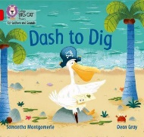  Dash to Dig (15 minutes teach, 15 minutes apply) | Fix it Fox (15 minutes teach, 15 minutes apply) | 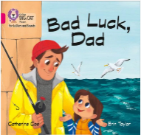  Bad Luck, Dad (15 minutes teach, 15 minutes apply)
Session 1: Teach phonemes ng, j, x, zz | Session 1: Teach phonemes qu, ch, sh, th, nk | Session 1: Teach phonemes v, y, m | Session 1: Teach phonemes g, o, ck, ff, ss, ll, e, u, r
Session 2: Teach and practise tricky words the, her, he, full | Session 2: Teach and practise tricky words and, to, the, we, be | Session 2: Teach and practise tricky words yak, zips, fix, van and man | Session 2: Teach and practise tricky words as, I, no, go, huffs, rod, fin, cod, luck
Session 3: Fluency- focus on blending new words with taught sounds | Session 3: Fluency- focus on expression of characters in a text | Session 3: Fluency – focus on role of punctuation and expression | Session 3: Fluency – focus
Session 4: Comprehension | Session 4: Comprehension | Session 4: Comprehension | Session 4: Comprehension
Session 5: Inference | Session 5: Inference | Session 5: Inference | Session 5: Inference
Additional interventions: daily reading

