Phase 4 (6 weeks)- Little WANDLE intervention (teach and apply sequences)
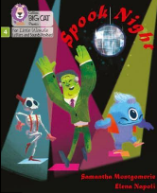  Spook Night (15 minutes teach, 15 minutes apply) | 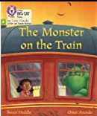  The Monster on the Train (15 minutes teach, 15 minutes apply) | I love it! (15 minutes teach, 15 minutes apply) | 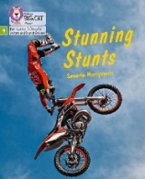  Stunning Stunts (15 minutes teach, 15 minutes apply) | 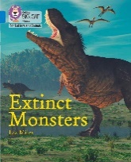  Extinct Monsters (15 minutes teach, 15 minutes apply) | 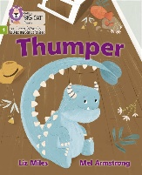  Thumper (15 minutes teach, 15 minutes apply)
Session 1: revise phonemes (phase 3) ee, oo, ar, oa, oo, ar, igh  Teach blends of adjacent consonants with long vowel phoneme sl, st, fl, sw, sc, sp | Session 1: revise adjacent consonant blends: cr, tr, sc, gr, st, br, gl | Session 1: revise adjacent consonant blends: br, fl, gr, sc, cl, sn, sl, ts, pl, sh | Session 1: revise adjacent consonant blends: st, sc, fl, sw, sp, tr, thr, ng, mp | Session 1: revise adjacent consonant blends: tr, th, nt, gr, sc, sw, sp, st, fl, ct | Session 1: revise adjacent consonant blends: nd, gs, cr, ck, cl, ps, sp, ts, br, ngs, sk, st, ng
Session 2: tricky words and specific vocabulary for the text:  do, you, go, to, the, come, all, he, be, they, have, she, into  spook, bops, glee | Session 2: tricky words and specific vocabulary for the text: are, I, into, is, me, my, of, on, to, some, the, we, you  creeps, scanning, slinks, spurts, clambers, flee | Session 2: tricky words and specific vocabulary for the text: of, he, I, you, the, love, come, like, do  complains, lagoon, shrimp, wails | Session 2: tricky words and specific vocabulary for the text: so, out, no, one, by, are  stunning, stunt, screech, flip, swoop, spears, train, thrilling | Session 2: tricky words and specific vocabulary for the text: little, was + any tricky not yet grasped from previous books  extinct, roosted, jutted, darted, flailing, barbs | Session 2: tricky words and specific vocabulary for the text: chomps, snaps, thwack, crops, naps (plus revision of new vocabulary from previous texts)
Session 3: Fluency- emphasis on expression. Model rhythm of the story | Session 3: Fluency- emphasis on character’s emotions through use of expression | Session 3: Fluency- emphasis on punctuation and pace of reading (the use of inverted commas, exclamation marks and commas) | Session 3: Fluency- emphasis on key words (text marking) | Session 3: Fluency- focus on features of non-fiction texts (headings/subheadings, annotations/labels, diagrams) | Session 3: Fluency- expression of different character’s to reflect mood- look at dialogue (model how to present this in a play script)
Session 4: Comprehension | Session 4: Comprehension | Session 4: Comprehension | Session 4: Comprehension | Session 4: Comprehension | Session 4: Comprehension
Session 5: Inference | Session 5: Inference | Session 5: Inference | Session 5: Inference | Session 5: Inference | Session 5: Inference
Additional interventions: daily reading

