Phase 5 (6 weeks)- Little WANDLE intervention (teach and apply sequences)
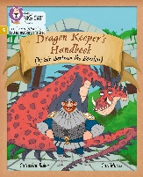  Dragon Keeper’s Handbook (15 minutes teach, 15 minutes apply) | Jake and the Jen in the Balloon of Doom (15 minutes teach, 15 minutes apply) | 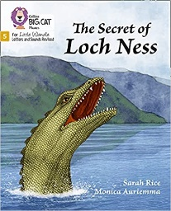  The Secret of Loch Ness (15 minutes teach, 15 minutes apply) | 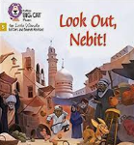  Look Out, Nebit! (15 minutes teach, 15 minutes apply) | 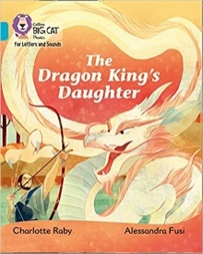  The Dragon King’s Daughter (15 minutes teach, 15 minutes apply) | 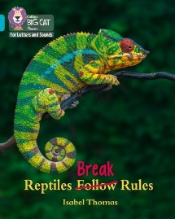  Reptile Break Rules (15 minutes teach, 15 minutes apply)
Session 1: revise phonemes (phase 5): ay, oy, ea, ou, ir | Session 1: revise phonemes (phase 5): a-e, e, ie, i, i-e, o, o-e, ew, u-e, aw | Session 1: revise phonemes (phase 5): a, tch, ture, oul, sc, ch, a, al, ear, or | Session 1: revise phonemes (phase 5): e, ea, ee, y, f, ph, igh, y, j, g, l, le, oa, ow, oo, ou, s, se, u, o | Session 1: revise phonemes (phase 5): ey, dge, ge, gn, kn, augh, oar, our, ssi, ti, si, su | Session 1: revise phonemes (phase 5): ea, ey, ge, kn, gn, si, y, mb, ti, ci
Session 2: tricky words and specific vocabulary for the text:  By the do you have we are to like some here they of be my all go I what  Vocab: fearless fuel broth quests pests damsel | Session 2: tricky words and specific vocabulary for the text: the said there’s to into my pulled of what asked some should could they were when their our you  Vocab: newborn sniggered prey sibling | Session 2: tricky words and specific vocabulary for the text: the of people aid to they are were their one sure  Vocab: glimpsed claimed emerging researcher samples hoax | Session 2: tricky words and specific vocabulary for the text: to of the oh are where one into all their there your friend push  Vocab: opulent scuttles fuming fragrant | Session 2: tricky words and specific vocabulary for the text: the to of any said are because their many into were  Vocab: gnashed mission centipede numb | Session 2: tricky words and specific vocabulary for the text: the eyes their to are move of many one  Vocab: appearance rivals submerged predators
Session 3: Fluency- emphasis on expression. Model rhythm of the story | Session 3: Fluency- emphasis on character’s emotions through use of expression | Session 3: Fluency- emphasis on | Session 3: Fluency- emphasis on) | Session 3: Fluency- focus on | Session 3: Fluency-
Session 4: Comprehension | Session 4: Comprehension | Session 4: Comprehension | Session 4: Comprehension | Session 4: Comprehension | Session 4: Comprehension
Session 5: Inference | Session 5: Inference | Session 5: Inference | Session 5: Inference | Session 5: Inference | Session 5: Inference
Additional interventions: daily/weekly reading

