Reading Journey MTP Autumn 1 – Year 5

Teaching Weeks (3 weeks)  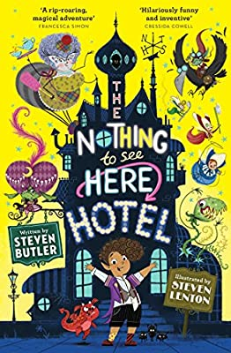 |  |  | Independent Application (3 weeks)
Week 1 | Week 2 | WK 3 | WK4 | WK5 | WK6
Prediction | Bank holiday | Infer feelings | Infer feelings | Fluency | Themes and conventions
Prediction/ Themes and conventions | Comprehension | Comprehension | Comprehension | Inference | Language
Fluency | Inference | Word meaning | Themes and conventions (teach) |  | Fluency
Different perspectives | Language | Fluency  Word meaning | Fluency | Word meaning | Word meaning
 | Drama fluency |  | Retrieve information | Infer feelings | Themes and conventions
Queen’s assembly
Reading Journey MTP Autumn 2 – Year 5

Teach |  |  |  | Apply
Week 1 | Week 2 | Week 3 | Week 4 | Week 5 | Week 6 | Week 7
Inset | Justify opinion with evidence | Art day | Inference | Prediction | Fluency | Fluency week
Prediction | Retrieve information | SPaG paper | Healthy living day | Fluency | Language
Language/word meaning | Inference | Inference | Impact of language choices | Predict using inference | Prediction | Christmas lunch
Fluency | Language/word meaning | Retrieve information | Justify opinion with evidence | Fluency |  | Fluency
Comprenshion | Read with fluency |  | Reading for pleasure | Fluency

Reading Journey MTP Spring 1- Year 5

Week 1 | Week 2  Teach | 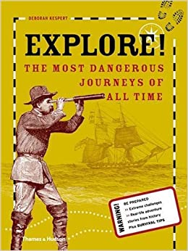  Week 3  Apply | Week 4  Playscripts  (Oliver Twist and Pinch of Salt)  Teach | Week 5  Poetry (various)  Teach/Apply | Week 6  Poetry (various)  Teach/Apply
Bank holiday | Justify facts and opinions | Fluency  Understand difference between fact and opinon | Themes and conventions | Fluency | Inference
Inset day | Fluency | Unpick language  (Over 2 lessons) | Inference  (Over 2 lessons) | Inference | School trip
Topic days | Unpick language meaning |  |  | Industrial Action day | Language meaning
Topic days | Retrieve information | Themes and conventions | Comprehension | Themes and conventions | Inference
Topic days | Retrieve information | Retrieve information | Inference | Inference | Unpick use of Language

Reading Journey MTP Spring 2
Teaching Week | Independent application week | Apply | Apply  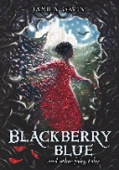 | 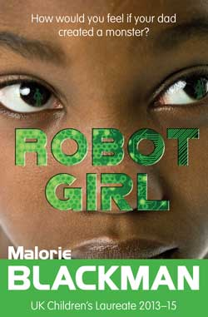
WK 1- Blackberry Blue | WK2-  Blackberry Blue and The Night Princess | WK3-  The Night Princess | Week 4 –  The Night Princess and Robot Girl | Week 5 – Robot Girl | Week 6 – Robot Girl
Predict | Predict | Fluency | Language | Fluency | Inference
Fluency- expression
 |  |  |  | Comprehension | Fluency
Vocabulary | Inference | Industrial action | Fluency | Language choices | Prediction
Comprehension | Topic day | Language | Making connections | No reading | Inference
Making connections | Comprehension | Fluency | Prediction | Inference | Fluency

Reading Journey MTP Summer 1
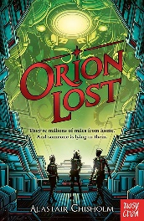

WK 1-  Orion Lost | WK2-  Orion Lost | WK3-  Orion Lost | Week 4 –  Orion Lost | Week 5 –  Orion Lost | Week 6 –  Orion Lost
Topic Day | Unfamiliar vocabulary | Bank holiday | Bank holiday | Language – changing meaning | Inference
Topic Day | Retrieving information | Fluency – impact of punctuation | Comprehension (continued from Friday) | Unfamiliar vocabulary | Prediction
Topic Day | Infer information | Prediction | Summarise and evaluate | Language choices | Retrieving information
Topic Day | Fluency and Comprehension | No reading – colour run |  | Making connections | No reading – internal testing
Fluency |  | Comprehension | Fluency | Unfamiliar vocabulary | Art Day

Reading Journey MTP Summer 2
 |  | 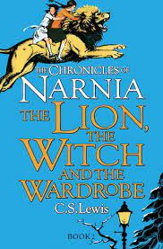
WK 1-  Orion Lost | WK2-  Orion Lost | Week 3 –LTWW | Week 4 - LTWW | LTWATW | LTWATW
Inset day | Unfamiliar vocabulary | Inference | Inference
Retrieving information | Fluency – impact of punctuation | Fluency | Summarise
Inference |  | Unfamiliar vocabulary | Skimming and scanning
Fluency | Maths day | Mental health team workshop | Strike day
Topic day | Topic day | Sports day | Strike day

