Reading Journey MTP Autumn 1

Teaching Weeks (2 weeks)  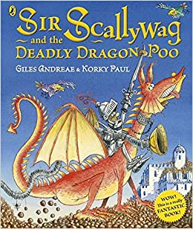 |  | Independent Application (2 weeks) 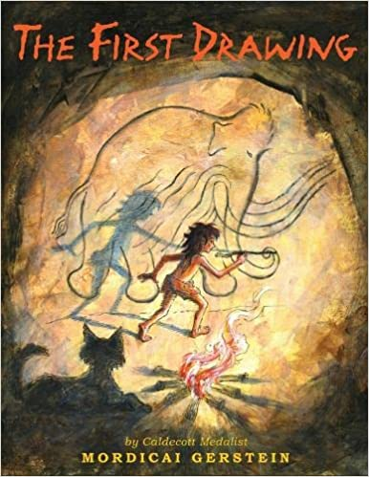
WK 1 | WK2 | WK 1 | WK2
Predict | Visualisation | Predict | Visualisation
Predict | Comprehension | Predict | Language
Fluency | Predict | Fluency | Comprehension
Language | Fluency | Summarise (teach) | Inference
Summarise | Inference | Inference | Make Links

Reading Journey MTP Autumn 1: Non-Fiction Unit
Teach Stage (1 week)  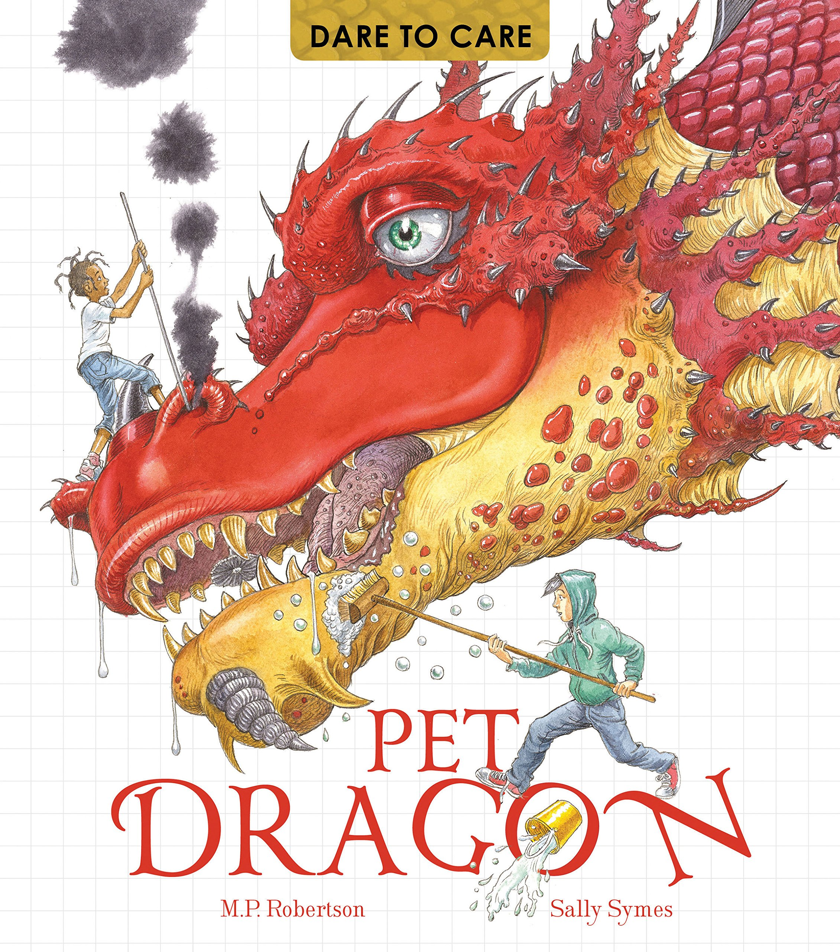 | Independent Application (1 week)
WK 1- Autumn 1 | WK 1- Autumn 1
Evidence | Evidence
Presentation (author style) | Language
Language | Presentation (author style)
Comprehension | Comprehension
Presentation | Presentation

Reading Journey MTP Autumn 2

Teaching Weeks (2 weeks)  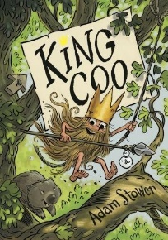 |  | Independent Application (2 weeks)
WK 1 | WK2 | WK 1 | WK2
Prediction | Fluency | Inferences | Inferences & evidence
Fluency | Summarising |  | Prediction
Inferences | Inferences | Extra teach needed- comprehension | Language
Comprehension | Fluency | Comprehension | Fluency
Language | Asking questions | Inference | Extra teach needed- comprehension

Reading Journey MTP Autumn 2: Extra Exception Week
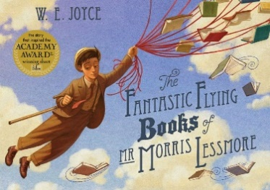
1 WEEK
Inference
Language
Language
Comprehension
Inference and evidence

Reading Journey MTP Spring 1: Short Non- Fiction Unit
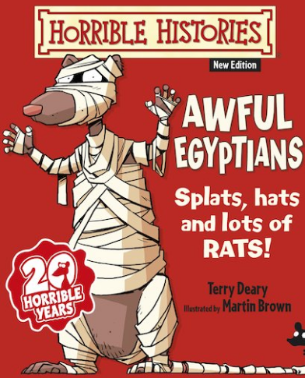
1 -2 WEEKS (Teaching Non-fiction Skills)
WK1 | WK2
Reading for meaning (Teach) | Recalling information from notes (Apply)
Note taking (Teach) | Reading for meaning (Teach)
Note taking (Apply) | Reading for meaning/pleasure (Apply)
Note taking and organisation features (Teach) | Reading for meaning/pleasure (Apply)
Recalling information from notes (Teach)

Reading Journey MTP Spring 1 and 2 Novel

Teach Phase (3 Weeks) |  |  | Apply Phase (3-4 Weeks)
WK1 | WK2 | WK3 | WK4 | WK5 | WK6 | WK7
Predict | Comprehension | Visualisations | Comprehension continued (teach) | Predict | Visualisations | Inferences
Predict |  | Fluency | Fluency | Fluency | Fluency | Themes and Conventions
Fluency | Summarising | Evidence and inferences | Summarise (half term break in text) | Language | Reader reactions (RATA)
Language- Reader Reactions (RATA) |  | Language | Leave 2 lessons clear for extra events. | Themes and Conventions (extra teach) | Comprehension
 | Evidence | Comprehension |  |  | Fluency

Reading Journey MTP Spring 2: Escape From Pompeii
TEACH  Week 1 | APPLY  Week 2
Inference | Inference
Language | Inference
Fluency | Language
Evidence | Fluency
Inference | Evidence
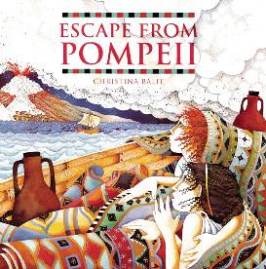

Reading Journey MTP Spring 2: Extra Exception Week
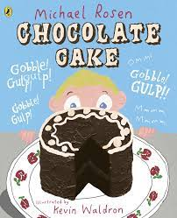
1 WEEK
Inference
Language
Language
Comprehension
Inference and evidence

Reading Journey MTP Summer 1 Novel

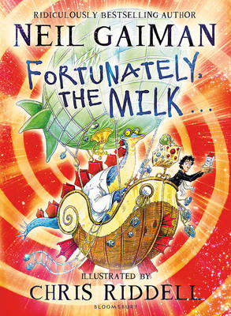  Teach Phase (3 Weeks) |  |  | Apply Phase (3-4 Weeks)
WK1 | WK2 | WK3 | WK4 | WK5 | WK6
Fluency | Comprehension | Bank Holiday | Fluency | Summarise and inference | Fluency and word meaning (2 lessons)
Inference | Language | Year 3 Geog Day | Visualisation | Comprehension
Predict | Visualisation and Collecting Evidence (2 lessons) | Summarise and order | Inference | Language (2 lessons) | Asking questions (2 lessons  )
 |  |  | Prediction
Summarise |  | Asking questions | Summarise | Fluency and Prediction
Language | Fluency | Comprehension |  |  | Themes and conventions (teach)

Reading Journey MTP Summer 2

Teach Phase  (4 Weeks) |  |  |  | Apply Phase  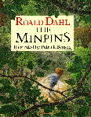  (2 Weeks)
WK1 | WK2 | WK3 | WK4 | WK5 | WK6
Inference | Fluency | Comprehension | Inference | Inference
Reading | Summary | Inference | Sports Day | Language for effect | Inference
Visualisation | Inference | Fluency | Language | Inference | Prediction
Inference | Inference | Themes and conventions | Inference | Language for effect | Summary
 |  |  |  | Inference | French day

