Reading Journey MTP Autumn 1 and 2 – Year 4

Teaching Weeks (5 weeks) |  |  |  |  |  | Independent Application (5 weeks)
Week 1 | Week 2 | Week 3 | Week 4 | Week 5 | Week 6 |  | Week 7 | Week 8 | Week 9 | Week 10 | Week 11
Predict | Visualisation | School Trip | Opinion | Summary | Inference |  | Comprehension |  | Fluency | Inference | Inference
Comprehension | Fluency | Comprehesnion | Language | Comprehension | Opinions |  | Comprehension | Inference | Language | Fluency | Inference
Inference | Language | Inference | Fluency | Inference | Fluency |  |  | Opinion | Inference | Themes | Comprehension
Inference | Inference | Inference | Fluency | Themes and conventions | Language |  | Inference | Inference |  | Comprehension | Comprehension
Language | Comprehension (paper) | Inference | Summary | Comprehension | Prediction |  | Summarising | Opinion | Language | Language | Inference

Grey indicates calendar events

Reading Journey MTP Autumn 1 and 2 – Year 4

Teaching Weeks (1 week)  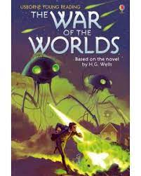 | Independent Application (2 weeks)
Week 1 | Week 2 | Week 3
Prediction |  | Language
Language |  | Fluency
Fluency | Fluency | Comprehension
Inference | Summarising | Prediction
Comprehension | Inference - prediction | Themes and conventions

Grey indicates calendar events

Reading Journey MTP Spring 1 – Year 4
Teaching Week  (1 week)  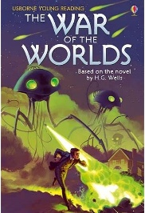 | Independent Apply  (1 week) | Teaching week  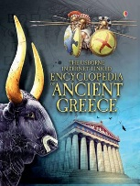  (1 week) | Independent Apply  (1 week)  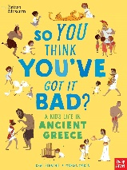 | Teaching week  (1 week)  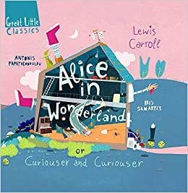 | Independent Apply  (1 week)
Week 1 | Week 2 | Week 3 | Week 4 | Week 5 | Week 6
 | Language | Language- new vocabulary | Themes and conventions
 | Fluency | Themes and conventions | Language- effect on reader | Themes and conventions
Fluency | Comprehension | Structure | Structure | Language | Fluency
Summarise | Predict | Comprehension | Comprehension | Infer | Infer
Predict | Themes and conventions | Fluency- expression | Fluency- punctuation | Word Meaning | Prediction

Reading Journey MTP Spring 2 – Year 4
Teaching Week  (1 week)  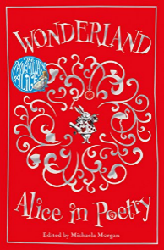 | Independent Apply  (1 week) | Teaching week  (1 week) | Teaching week  (1 week) | Independent Apply  (1 week) | Independent Apply  (1 week)
Week 1 | Week 2 | Week 3 | Week 4 | Week 5 | Week 6
Fluency | Comparison | Language | Themes | Language | Fluency
Language/Structure | Language/structure | Prediction | Retrieval | Inference | Summarise
Retrieval | Summarise | Retrieval | Language | READING TEST | SORA
Patterns in language |  | Fluency | Summarise | Retrieval | SORA
Summarise | Fluency | Retrieval | Prediction | Inference | Art day

Reading Journey MTP Summer 1 – Year 4
Week 1 – Teach  Ice Trap! | Week 2 – Apply  Ice Trap! | Week 3 – Teach  Odd and the Frost Giants | Week 4 – Teach  Odd and the Frost Giants | Week 5 – Apply  Odd and the Frost Giants | Week 6 – Apply  Odd and the Frost Giants
Reading Test revision | Reading Test revision | BANK HOLIDAY | BANK HOLIDAY | Prediction  81-82 | Language (visualisation)  98-102
Language | Language | Comprehension  36-41 | Language (visualisation)  56-59 | Fluency (expression)  86 | Summary  103-105
Fluency | Inference | Compare characterisation  45-46 | Prediction  60-64 | Retrieval/comprehension  88-94 | Fluency (punctuation/pace)  108-112
Fact and opinion | Retreival | Inference  50-52 | Fluency (expression)  66-70 | Inference  96-97 | Inference  114-116  Compare characterisation  117-120 (end)
Inference | Summarise | Retrieval/comprehension  53-56 | Summary  74-80 | Compare characterisation  - | SURVIVAL DAY

Reading Journey MTP Summer 2 – Year 4
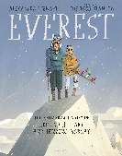  Week 1 – Teach | Week 2 – Teach | Week 3 – Apply | Week 4 – Apply | Week 5 – Teach  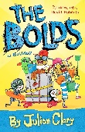 | Week 6 – Apply
INSET | Retrieval – comprehension | Healthy Relationships | Prediction | Stamina and fluency | Fluency
Prediction | Fluency | Retrieval – 5 ws | Structure and layout | Stamina and fluency | Language
Retrieval – 5 ws | Note taking | Retrieval | Comprehension | Stamina and fluency | Prediction
Fluency | Comparisons | Inference | Comparisons |  | Word meaning
Sequencing | Summarising | Fluency | Sports day

