
Expected Service Premium Funding Expenditure:

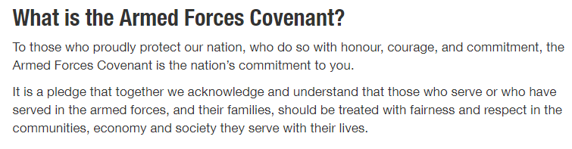
Report to parents: 2023-24

Service Premium Provision may include:

- My Passport programme for all service children joining with a focused pastoral adult
- Providing support for pupils undergoing induction or significant transition (e.g. moving schools) to ensure progress is maintained
- Extra-curricular activities intended to promote confidence, wellbeing and success for military children or promoting an awareness of their life and experience for other pupils. This includes additional activities and support during deployment
- Pastoral support from our ELSA and Camo leads so pupils are ready to learn, particularly when there is turbulence such as deployment within the family, including understanding of the turbulence experienced when adults return
- Interventions and closing the gap teaching for children who have had turbulence within their education and have gaps in key concepts or skills, including pre-teaching of technical language and an understanding that children may speak English as an Additional Language (EAL)
- Outcomes and provisions embedded from the Thriving Lives Tool Kit Evaluation (produced Autumn 2021)
- Effective use of research from the Education Endowment Fund (EEF) in order to provide the most cost-efficient and therefore widest spread benefit to service pupils

Overview of the School
Number of pupils and Service Pupil Premium Funding (PPF) received
Total number of pupils on roll | 408
Number of service children | 269
Total amount of SPPF received | £91,115 (£335 per pupil)

Activity and Resource | Cost | Expected Impact
Additional adult support for children who need emotional support through ELSA (Emotional Learning Support Assistant) programmes, including personalised programmes, personalised intervention and ‘bubble’ time to promote children’s social skills, wellbeing and confidence. Support offered to children when parents on deployment through our Camouflage Club that gives time for discussion, communication and activities that help build links with the absent parent.  Wider events planned to demonstrate school-wide support such as Reading Force, Camp out, Tag Rugby etc | £4,500 | ELSA provides programmes for identified children with the intention to provide personal emotional support, which therefore prepares them to learn.  Impact is measured through reassessment at the end of programme with evidence of difference.  Camouflage club – opportunity to discuss any concerns so they are ready to learn.  Parental engagement supports children’s wellbeing and good links between families and school allow for early identification of concerns
Continued training for ELSA (x2 lead) to develop knowledge and skills in programmes to best meet the needs of our children. Further training in Lego therapy, education psychologist training  MHST referrals made as needed and staff trained in the identification of concerns around children’s wellbeing | £3,000 | By developing staff skills and knowledge, more children can be given appropriate guidance and support that better meets their needs.
My Passport programme maintained across the school. All new arrivals and leavers access the My Passport programme with an LSA. Monitoring of pupils settling process and transition. Ensure transition is smooth and pupils quickly make progress. Children’s entrance levels assessed and gaps assessed. EAL level assessed if appropriate. EMTAS service used as needed. My Passport analysed and results fed back to SLT. | £5,000 | Children settle quickly and are ready to learn. Children’s transition to new schools is smooth and children achieve their best asap. Teachers are aware of any gaps and attainment accurate.  Bell Foundation assessment used to ensure teachers and LSAs are able to provide the most effective support for learning as soon as possible. Bell Foundation assessments inform planning at the child’s level.
Maintain and develop the provision provided by Parent Partnership Advisors  Workshops and courses run for parents/ including dealing with angry children/ Top Tips for Parents/ anxiety and 1:1 support where needed.  Supporting Attendance through Education Welfare Officer. | £4,000 | Induction to Talavera is successful with children quickly adapting to their new school. Links between home & school are positive with increasing involvement by parents evident in attendance for school activities, workshops and meetings.  Parents immediately become part of the community. Teachers and LSAs can identify when families may need additional support and know the support that is available at Level 1 (universal).
Additional support for EAL children who are new to English or their English Language skills are weak through Bilingual Assistant. Children moving from abroad with the army or where English is not their first language at home. A high portion of our service families do speak English as an additional language. Bilingual Assistant to translate, develop parent relationships and communication.  EAL bank of resources for all entrance levels, which supports T and L/ children settling quickly. Profile of EAL learners raised through purchasing of level-appropriate books. ‘Ambassadors for pupils’ demonstrating best practice from EMTAS.  Bell Foundation used to assess pupils where needed – where teachers believe children are Code A or B (new to English). ELKLAN training attended by key staff members and disseminated to all staff. | £8,000 | Improving confidence and skill in English language making impact on progress. Target closing the gap to expected– see intervention analysis. Increase fluency levels of new arrivals. Where needed, individualised instruction supports the immersion of EAL pupils. Phonics programmes may be used to support this too. Staff CPD allows for them to effectively support children using phonics. Language for Thinking programme embedded, all LSAs trained and children with additional language needs (not EAL) are supported to access the curriculum. ELKLAN is embedded for children with Speech and Language difficulties and all children benefit from good practice.
With our high levels of turbulence, some of our service premium money contributes towards costs of trips which we see as a valuable part of children’s learning enriching the children’s experience and understanding of the curriculum. Rewards which provide experiences beyond the classroom and may not be accessible to all children will also be provided. This includes support for pupils currently assessed at, or with the potential to be, GDS. | £3,000 | All children enjoy a wide range of visits, visitors and activities that provide first-hand experiences which add to their learning.  Experiences which enrich our core values and high expectations. Children can fully access the curriculum. All learners are challenged appropriately and all have high aspirations. The school reaches out to members of the community who are able to provide inspiration to pupils, academically, socially or in another area.
Additional admin time in the school office to meet the needs of high turbulence and to maintain and manage our school website/ information media. It is a valuable learning resource and information source for all our parents and helps particularly service families keep in touch with our school. Additional new entrances/liaising with schools/school tours/ My Passport analysis. Attendance follow-up for workshops (see below). | £8,000 | Parents can easily access information about the school and its many activities, homework and other resources that enable the children to be well supported by their families wherever they may be. All documents and applications are quickly processed.
Reading, spelling and maths targeted workshops- support for parent/carers on supporting their child to ensure they are in line with National Standard and understand the expectations/ content of the curriculum. Focusing on supporting parent/carers with strategies and resources to use at home. All year groups. All service children to receive free resources, books and packs to support learning at home. 100% attendance expected. Additional focus on reading to ensure love of reading and availability of texts. Strong links made with local library in order to raise the profile of reading in the community. | £3,200 | Children improve their understanding of maths and reading in line with the curriculum. To increase the percentage of service premium children who are at national standard across all year groups through closing the gap. Focused parents/children invited. Parents able to support learning and methods to ensure fluency and love of reading.  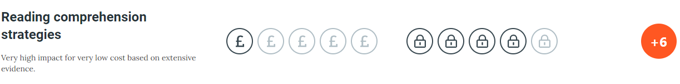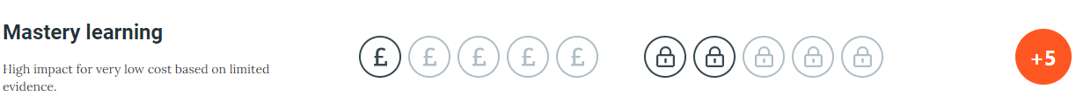
Additional and part-funded extended opportunities for service premium children. Clubs (often more than one) are offered every day after school and some before school. These are at a nominal rate. This supports our service families’ particularly when one member is deployed. Service premium children (along with disadvantaged children) prioritised for in-school events designed to raise parental engagement. | £2,500 | All children can access the extended opportunities and have as wide curriculum as their peers. Their engagement is transferable into learning within the classroom.  Service premium children integrated into the community.  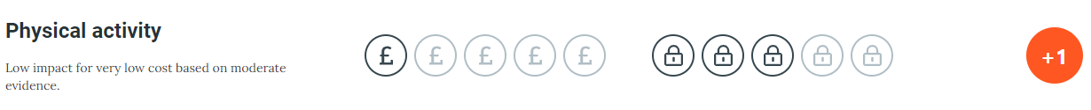
Target children having regular intervention work with teachers, HLTAs & Learning Support Assistants to help close the gap of progress and increase the number of children at ARE by end of the year. Interventions are robust, frequent and reviewed regularly (at least each phase). The focus is immediate intervention.  Time given to pre-teaching of technical language to ensure language-rich classrooms. Identification of challenges where needed if pupils have previously studied a curriculum area. | £14,000 | Year group data to show at least 70% children in all year groups achieve ARE in Reading, Writing and Maths. 2019-2020 – target 85% R/W/M. Metacognition skills are taught to all children through effective CPD of teachers and LSAs. Teachers and LSAs can confidently support pupils to understand their learning and how the learning process  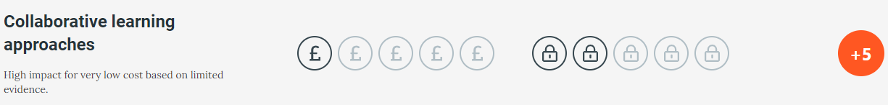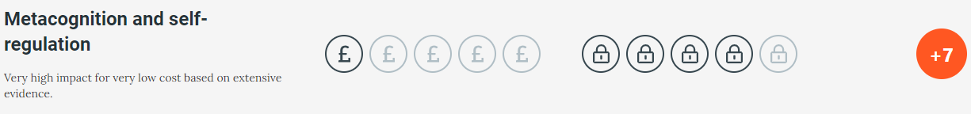
Conferencing 1:1 in the afternoon immediate intervention re: learning in the morning. Closing the gap re: Expected. Support embedding challenge/closing the gap and explanation feedback for target children. Class LSA/ HLTA/ focus teachers’ immediate intervention – children who have been to several schools and have gaps.  Time given to pre-teaching of technical language to ensure language-rich classrooms. Identification of challenges where needed if pupils have previously studied a curriculum area. | £12,000 | Focus children in all year groups closing the gap to national standard. 80% target being met. Quality feedback in topic/maths books.  Children with the potential to work at Greater Depth Standard (GDS) are supported to achieve this.
Homework supports all children. Homework clubs offered to pupils during school day and extended hours. Times Table Rockstars programme is embedded in all year groups. Effective use of Times Table Rockstars is made in school and at home. Competition and events to celebrate achievements of children are embedded into the curriculum in a way which is supportive of all. | £1,000 | Impact on number skills/ fluency and improve % of children at national standard for mathematics across the school.  Provides additional out of school hours support for any children with gaps or not at national standard. Families feel supported with homework and understand how to support their children in turn.
Running events, which integrate our service families and develop community cohesion - Camo Day, Nepali Day, Fijian Day, Family Camp Out. Engagement in wider community events, such as St. Patrick’s Day parade and Victoria Day. | £4,500 | Further integrate our community and understand our different backgrounds. Celebration of our different service children and the range of backgrounds that they represent. All staff understand that service pupils represent a wide range of abilities and needs. Children enjoy school and feel celebrated. All children understand the role that service families play in our community. Rich experiences offered to all children.
Fast Tracking year 5 and 6 service children who have to ‘close the gap to national standard’. Often these children start in year 5, or upper school. Supported before school to support closing the gap HTLAs/ teachers and SLT. Sessions every morning linked to reading and maths. | £8,000 | Closing the gap to national standard – children secondary ready with good understanding of the role of learning throughout our lives. Life chances offered to all and options considered by all pupils.

Nature of support or expenditure for 2023-24
- Extra-curricular activities intended to promote confidence, wellbeing and success
- Providing support for pupils undergoing induction or significant transition (e.g., moving schools)
- Pastoral support from a qualified ELSA/ pastoral programmes
- Educational opportunities and life experiences which will enrich the pupils’ experience of school and learning (e.g. school trips and visits from professional and groups)
- Overcoming gaps and poor progress through ‘closing the gap’ teaching / intervention which is immediate and makes significant impact
Measuring the impact of SPF spending
Year 3 secure attainment 25 points.
All:
R: 24.2
W: 24.1
M: 24.4
RWM: 24.2
Non –Service Premium
R: 23.6
W: 23.9
M: 24.1
RWM: 23.9
Service Premium
R: 24.5
W: 24.3
M: 24.6
RWM: 24.5
Reading: 88% Good progress or better
Writing: 81% Good progress or better
Maths: 96% Good progress or better

Year 4 secure attainment is 28 points.
All:
R: 26.7
W: 26.4
M: 26.7
RWM: 26.6
Non –Service Premium
R: 28.4
W: 28.2
M: 28.5
RWM: 28.4
Service Premium
R: 27.7
W: 27.4
M-: 27.7
RWM: 27.6
Reading: 86% Good progress or better
Writing: 77% Good progress or better
Maths: 58% Good progress or better

Year 5 secure attainment is 31 points.
All:
R: 30.9
W: 30.8
M: 31.1
RWM: 30.9
Non –Service Premium
R: 30.8
W: 30.6
M: 31.0
RWM: 30.8
Service Premium
R: 31.1
W: 30.9
M: 31.2
RWM: 31.1
Reading: 87.5% Good progress or better
Writing: 97% Good progress or better
Maths: 99% Good progress or better

Year 6 SATs
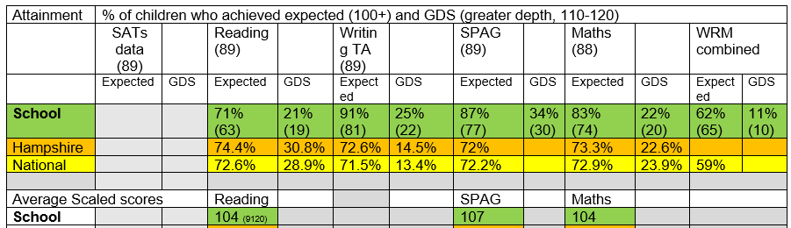

Service Premium Year 6 SATs
Reading:
Expected+: 67%
GDS: 15%

Writing:
Expected+: 94%
GDS: 23%

Maths:
Expected+: 79%
GDS: 17%

RWM:
Expected+: 56%
GDS: 10%

`
*Teaching and Learning Toolkit Sutton Trust impact included

