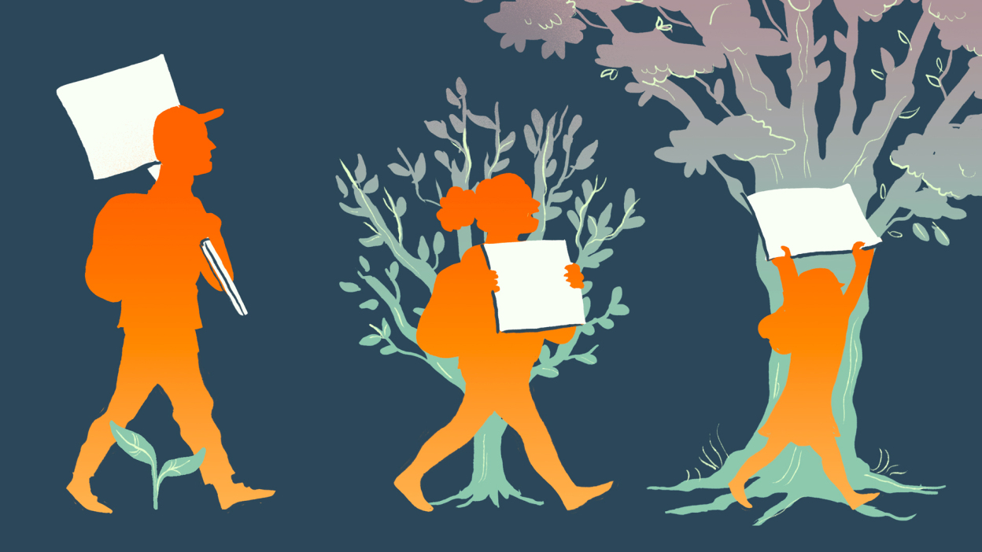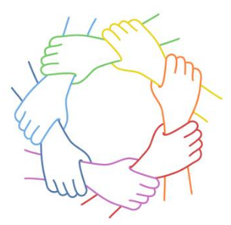 LO: To understand the core value of integrity (strong moral principles)

Now we know the definition of these two words, what do you think these last two sentences mean?

How does love make you feel?

List as many examples of where justice has happened.

How do you think we can 'grow' as people and a society if we work together? What do you think we could achieve or change?

What changes in the world do you want to see and would be willing to campaign for?

Fill in the poster to show **what life would look** like if all our rights are met.