Year 6 Reading Journey MTP Autumn 1
Teaching Weeks (2 weeks)  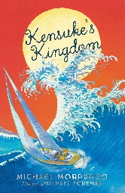 |  | Independent Application (3 weeks)
WK 1 | WK2 | WK 1 | WK2 | WK3
Predict | Fluency | Language | Language | Inference
Inference | Inference | Predict | Inference | Comprehension
Fluency | Comprehension | Visualisation | Fluency | Prediction
Summarise | Summary and Prediction | Fluency | Comprehension | Fluency
Visualisation | Language | Summarise | Make Links | Make Links

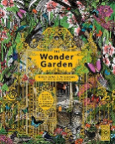  Teaching Week (1 week) | 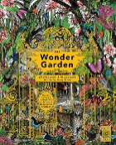  Independent Application (1 week) | 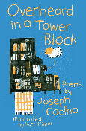  Teaching Week (1 week) | 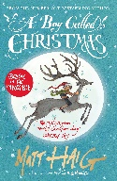  Teaching Week (2 weeks) | Teaching Week (2 weeks)
WK 1 | WK 2 | WK 3 | WK 4 | WK 5
Word meaning | Comprehension | Visualisation | Inference | Comprehension
 | Word meaning | Inference | Fluency | Prediction
Structure | Fluency | Comprehension | Comprehension | Inference
Inference | Structure | Themes and conventions | Language | Visualisation
Fluency |  | Language |  | Fluency
Reading Journey MTP Autumn 2

Apply Week (2 weeks) | Apply Week (2 weeks)
WK 6 | WK 5 (A3 sheet)
SATs week-fluency project | Summary
 | Prediction
 | Fluency
Reading Journey MTP Autumn 2

Reading Journey MTP Spring 1

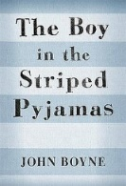  Teaching weeks (3 and a half weeks)  Themes and Conventions throughout planning |  |  |  | Apply weeks (3 weeks)
WK 1  03.01.22 | WK 2  10.01.22 | WK 3  17.01.22 | WK 4  24.01.22 | WK 5  31.01.22 | WK 6  07.02.0.22 | WK7  14.02.22
Fluency - understanding | Inference | Fluency | Inference | Inference | Themes and Conventions | Inference & prediction
 | Word meaning | Language & Themes and Conventions | Prediction | Fluency - understanding | Comprehension | Language (focus on emotive language)
 | Prediction | Comprehension | Comprehension | Language | Prediction | Inference
Inference | Comprehension | Inference | Themes and Conventions |  | Word meaning | Fluency and comprehension
Comprehension | Fluency | Themes and Conventions/  Fluency | Word meaning | Inference | Fluency
Reading Journey MTP Spring 2

Teaching Weeks (2 weeks) |  | Independent Application (3 weeks)
WK 1 | WK2 | WK 1 | WK2 | WK3
Fluency project- focus on reading pace, expression, understanding of vocabulary and comprehension test technique |  | Fluency project- focus on reading pace, expression, understanding of vocabulary and comprehension test technique

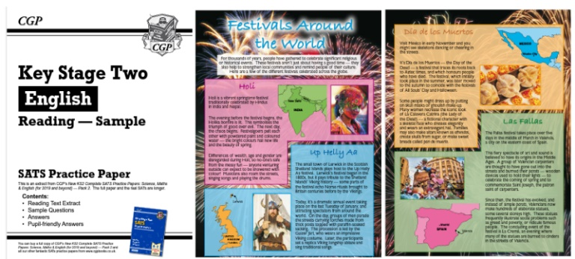
30 minutes of test technique reading journey sessions are also run daily in Spring 2 in preparation of SATs tests.

Reading Journey MTP Summer 1 and Summer 2
Teaching Week (3 week) |  |  | Independent Application (4 weeks)
WK 1 | WK 2 | WK 3 | WK 4 | WK 5
Prediction | Fluency | Prediction | Language | Inference
 | Comprehension | Themes and Conventions |  | Fluency
Fluency | Inference | Comprehension | Comprehension | Inference
Inference | Visualisation | Inference | Inference | Comprehension
Language | Language |  |  | Language
 |  |  | Themes and Conventions

Reading Journey MTP Summer 1 and Summer 2

Independent Application (4 weeks)

WK 6 | WK 5 (A3 sheet)
Fluency | Fluency
Inference | Inference
Prediction | Prediction
Comprehension
 | Comprehension

