Talavera Junior School

The times table square could be used for:

- Revising tables
- Exploring patterns
- Checking answers in independent work

We are having a big push in school on learning times tables! We often get asked at parents’ evenings what can be done to help children at home with their maths—learning times tables is a brilliant way of helping your child and it really can make a huge difference.

Name of child: ________________________________
x | 1 | 2 | 3 | 4 | 5 | 6 | 7 | 8 | 9 | 10 | 11 | 12
1 | 1 | 2 | 3 | 4 | 5 | 6 | 7 | 8 | 9 | 10 | 11 | 12
2 | 2 | 4 | 6 | 8 | 10 | 12 | 14 | 16 | 18 | 20 | 22 | 24
3 | 3 | 6 | 9 | 12 | 15 | 18 | 21 | 24 | 27 | 30 | 33 | 36
4 | 4 | 8 | 12 | 16 | 20 | 24 | 28 | 32 | 36 | 40 | 44 | 48
5 | 5 | 10 | 15 | 20 | 25 | 30 | 35 | 40 | 45 | 50 | 55 | 60
6 | 6 | 12 | 18 | 24 | 30 | 36 | 42 | 48 | 54 | 60 | 66 | 72
7 | 7 | 14 | 21 | 28 | 35 | 42 | 49 | 56 | 63 | 70 | 77 | 84
8 | 8 | 16 | 24 | 32 | 40 | 48 | 56 | 64 | 72 | 80 | 88 | 96
9 | 9 | 18 | 27 | 36 | 45 | 54 | 63 | 72 | 81 | 90 | 99 | 108
10 | 10 | 20 | 30 | 40 | 50 | 60 | 70 | 80 | 90 | 100 | 110 | 120
11 | 11 | 22 | 33 | 44 | 55 | 66 | 77 | 88 | 99 | 110 | 121 | 132
12 | 12 | 24 | 36 | 48 | 60 | 72 | 84 | 96 | 108 | 120 | 132 | 144

Target Times Table: ________________________

A times table will remain a target table, until a child knows the number facts in order and out of order.

1 x 2 = 2
2 x 2 = 4
1 x 3 = 3
2 x 3 = 6
1 x 4 = 4
2 x 4 = 8
1 x 5 = 5
2 x 5 = 10

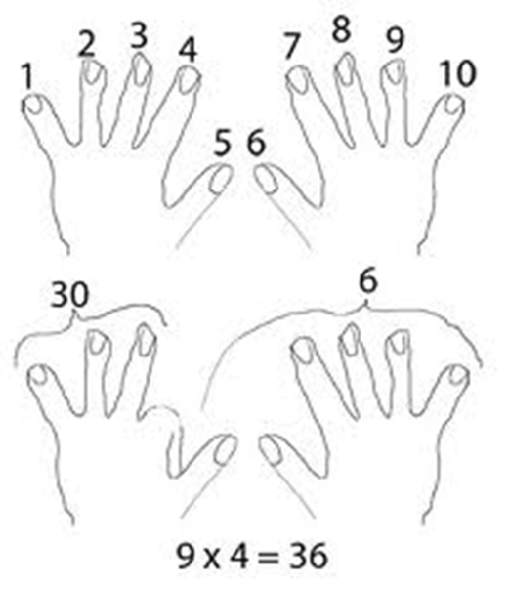
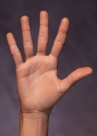
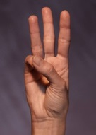
  - Hold your hands in front of you with your fingers spread out.
3 | x | 2 | = | 6 | 3 | x | 3 | = | 9 | 3 | x | 4 | = | 12 | 3 | x | 5 | = | 15
4 | x | 2 | = | 8 | 4 | x | 3 | = | 12 | 4 | x | 4 | = | 16 | 4 | x | 5 | = | 20
5 | x | 2 | = | 1100 | 5 | x | 3 | = | 15 | 5 | x | 4 | = | 20 | 5 | x | 5 | = | 25
6 | x | 2 | = | 1122 | 6 | x | 3 | = | 18 | 6 | x | 4 | = | 24 | 6 | x | 5 | = | 30
7 | x | 2 | = | 1144 | 7 | x | 3 | = | 21 | 7 | x | 4 | = | 28 | 7 | x | 5 | = | 35
8 | x | 2 | = | 1166 | 8 | x | 3 | = | 24 | 8 | x | 4 | = | 32 | 8 | x | 5 | = | 40
9 | x | 2 | = | 1188 | 9 | x | 3 | = | 27 | 9 | x | 4 | = | 36 | 9 | x | 5 | = | 45
10 | x | 2 | = | 20 | 10 | x | 3 | = | 30 | 10 x |  | 4 | = 40 |  | 10 | x | 5 = |  | 50
11 | x | 2 | = | 2222 | 11 | x | 3 | = | 33 | 11 x |  | 4 | = 44 |  | 11 | x | 5 = |  | 55
12 | x | 2 | = | 2244 | 12 | x | 3 | = | 36 | 12 x |  | 4 | = 48 |  | 12 | x | 5 = |  | 60
1 | x | 6 | = | 6 | 1 | x | 7 | = | 7 | 1 x |  | 8 | = 8 |  | 1 | x | 9 = |  | 9
2 | x | 6 | = | 12 | 2 | x | 7 | = | 14 | 2 | x | 8 | = | 16 | 2 | x | 9 | = | 18
3 | x | 6 | = | 18 | 3 | x | 7 | = | 21 | 3 | x | 8 | = | 24 | 3 | x | 9 | = | 27
4 | x | 6 | = | 24 | 4 | x | 7 | = | 28 | 4 | x | 8 | = | 32 | 4 | x | 9 | = | 36
5 | x | 6 | = | 30 | 5 | x | 7 | = | 35 | 5 | x | 8 | = | 40 | 5 | x | 9 | = | 45
6 | x | 6 | = | 36 | 6 | x | 7 | = | 42 | 6 | x | 8 | = | 48 | 6 | x | 9 | = | 54
7 | x | 6 | = | 42 | 7 | x | 7 | = | 49 | 7 | x | 8 | = | 56 | 7 | x | 9 | = | 63
8 | x | 6 | = | 48 | 8 | x | 7 | = | 56 | 8 | x | 8 | = | 64 | 8 | x | 9 | = | 72
9 | x | 6 | = | 54 | 9 | x | 7 | = | 63 | 9 | x | 8 | = | 72 | 9 | x | 9 | = | 81
10 | x | 6 | = | 60 | 10 | x | 7 | = | 70 | 10 x 8 = 80 |  |  |  |  | 10 | x | 9 = |  | 90
11 | x | 6 | = | 66 | 11 | x | 7 | = | 77 | 11 x 8 = 88 |  |  |  |  | 11 | x | 9 = |  | 99
12 | x | 6 | = | 72 | 12 | x | 7 | = | 84 | 12 x 8 = 96 |  |  |  |  | 12 | x | 9 = |  | 108

  - For 9 X 4 bend your fourth finger down (like the picture)
  - You have 3 fingers in front of the bent finger and 6 after the bent finger. Thus the answer must be 36!
  - This technique works for the 9 times tables up to 10.

This is a game for two players!

The game is basically a version of stone, pa- per, scissors but with numbers. Two players count to three and then make a number us- ing their fingers.

Both players then have to multiply both the numbers together and the quickest wins. The first to write the word SUPERFINGERS is the

Player 1

Player 2

winner!
1 | x | 10 | = | 10 | 1 | x | 11 | = | 11 | 1 | x | 12 | = | 12
2 | x | 10 | = | 20 | 2 | x | 11 | = | 22 | 2 | x | 12 | = | 24
3 | x | 10 | = | 30 | 3 | x | 11 | = | 33 | 3 | x | 12 | = | 36
4 | x | 10 | = | 40 | 4 | x | 11 | = | 44 | 4 | x | 12 | = | 48
5 | x | 10 | = | 50 | 5 | x | 11 | = | 55 | 5 | x | 12 | = | 60 | You will need a deck of cards for this game!
6 | x | 10 | = | 60 | 6 | x | 11 | = | 66 | 6 | x | 12 | = | 72
7 | x | 10 | = | 70 | 7 | x | 11 | = | 77 | 7 | x | 12 | = | 84 | 1. Flip over the cards as though you are
8 | x | 10 | = | 80 | 8 | x | 11 | = | 88 | 8 | x | 12 | = | 96 | playing Snap.
9 | x | 10 | = | 90 | 9 | x | 11 | = | 99 | 9 | x | 12 | = | 108 | 2. The first one to say the fact based on the
10 | x | 10 | = | 100 | 10 | x | 11 | = | 110 | 10 | x | 12 | = | 120 | cards turned over (a two and a three =
11 | x | 10 | = | 110 | 11 | x | 11 | = | 121 | 11 | x | 12 | = | 132 | Say "6") gets the cards.
12 | x | 10 | = | 120 | 12 | x | 11 | = | 132 | 12 | x | 12 | = | 144 | 3. The person to get all of the cards wins!

Sum = 5 x 3!

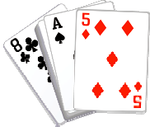

Silly rhymes can help children learn tricky tables, e.g.

8 x 8 = 64 He ate and ate and he sticks in the door, eight times eight
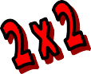
is 64.
6 x 6 = 36 Swing from tree to tree on a vine, three times three is nine. 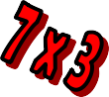
6 x 8 = 48 Six and eight got along great, multiplied together and they made forty eight.
I’m sure we all remember stand- ing up, chanting tables at school (I know I do!) Learning by rote is one strategy, but there are also other activities we can do with children to help them learn their tables.

The aim of this booklet is to show you some of the strategies we use in school and that you could try at home to help your child with their tables.

We hope you find it useful!

Children can write their own for the tricky multiplications . 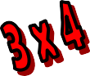
This is a strategy for learning the 9 x table. The key to it is that for any answer in the 9 times ta-
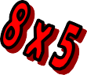
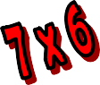
ble, both digits add up to 9. Try it and see!
- Subtract 1 from the number you are multiply-
ing by 9. Eg. 7 x 9, one less than 7 is 6
- This number becomes the first number in the answer. 7 x 9 = 6_
- The two numbers in the answer add up to 9
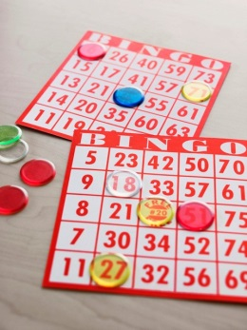
so the second number must be 3. 7 x 9 = 63
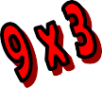 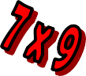 This game will need two players!
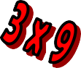
Make a grid of six squares on a piece of paper and ask your child to write a number in each square from the target table. Give them a question and if they have the answer, they mark the number off. First one to cross off all their numbers is the winner!

Six times table can be tricky to learn. One helpful trick is that in the 6 x table, when you multiply an even number by 6, they both end in the same digit:

2 x 6 = 12

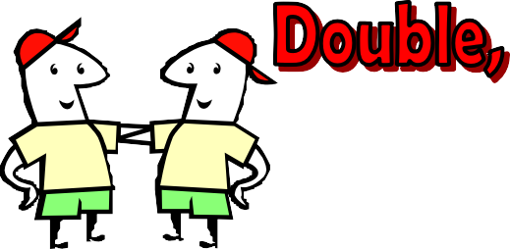
8 x 6 = 48

A quick trick for learning the fours is just to double, double. Double the number and dou- ble again.

E.g. 3 x 4 ............double 3 is 6, double 6 is 12..........3 x 4 = 12!

Singing tables can be a really good way for the children to learn. Most book shops and toy shops will have CDs of times tables songs that the chil- dren can sing along to, or you could always make up your own to a known tune!

Time challenges can be a really good way of helping times tables become automatic. Some ideas we use in school are:

- Measuring the time is takes to write the table, then trying to beat that time
- Seeing how many times you can write that table in one minute
- Races/challenges against other people
Being able to spot patterns in numbers is an important skill and can also help with learning tables. Children can investigate these multiplication rules:

- Odd number x odd number = odd number (E.g. 3 x 5 = 15)

- Even number x even number = even number (E.g. 4 x 6 = 24)

- Odd number x even number = even number (E.g. 3 x 6 = 18)

Once children know the times table facts in order, they can use flashcards to practice the facts out of order. They could just use them to answer questions, or for an extra challenge, try it against the clock!

Flash cards could also be stuck around the house to help children learn the facts!
http://www.woodlands-junior.kent.sch.uk/maths/ timestable/ (linked from our school website)

http://www.topmarks.co.uk/Flash.aspx?f=HitTheButtonv10 http://www.topmarks.co.uk/Flash.aspx?f=SpeedChallenge http://www.what2learn.com/home/examgames/maths/subtraction/
http://www.bbc.co.uk/skillswise/numbers/wholenumbers/ multiplication/timestables/game.shtml

Remember to check our website regularly for more websites!
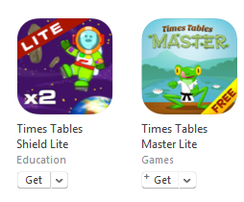
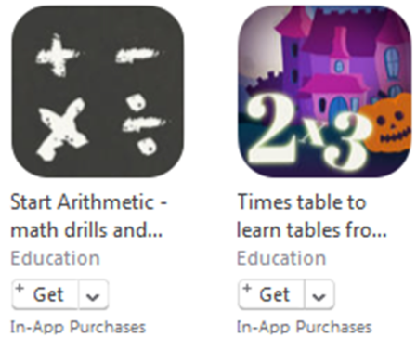
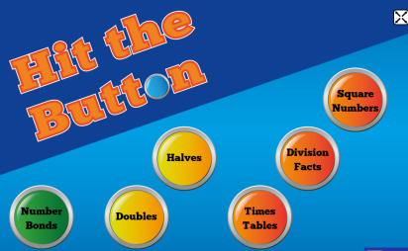
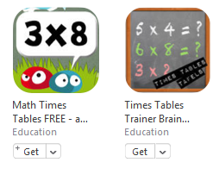
IPAD APPS

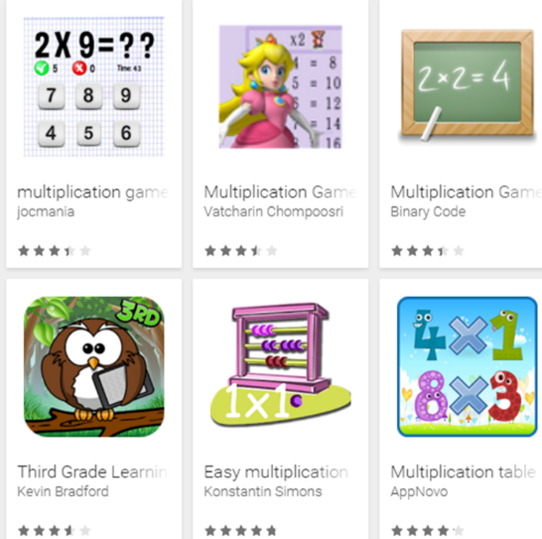
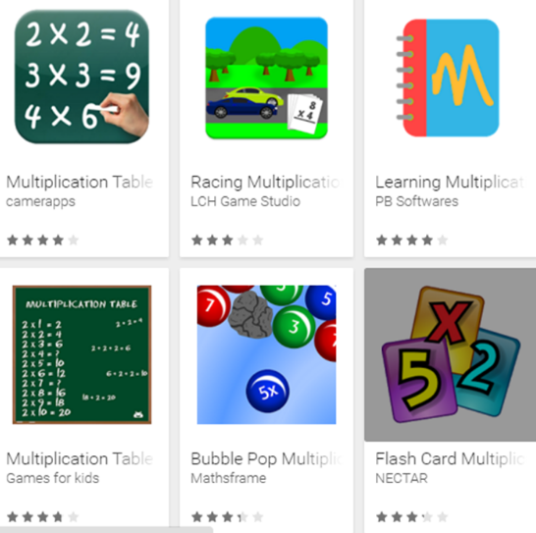
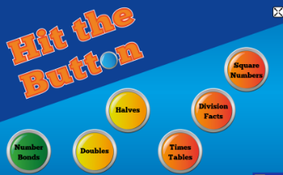
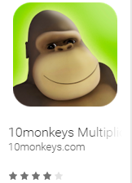
ANDROID APPS

